I.Bom
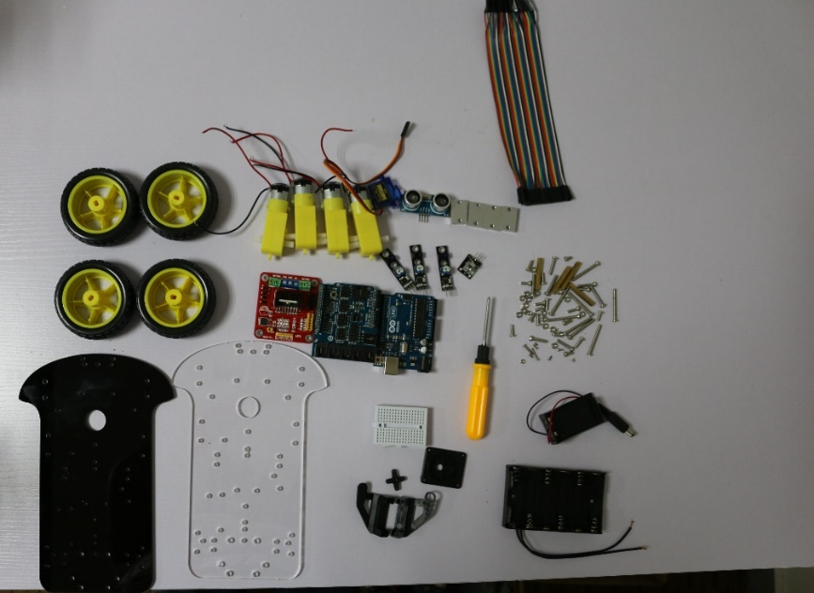
1. 4pcs motor
2. 4pcs motor fixed pieces
3. 2pcs robot chassis
4. 4pcs High quality type
5. 1pcs L298N motor driver board
6. 1pcs uno r3
7. 1pcs sensor extension plate V4
8. 1pcs 170 point breadboard
9. 1pcs holder
10. 1pcs SG90 servo
11. 1pcs ultrasonic sensor module
12. 3pcs TCRT5000 tracing module
13. 1pcs infrared receiving sensor module
14. 1pcs remote
15. 1pcs Six 5th battery box
16.1pcs Two 5th battery box
17. 1pcs 40pin dupont line
18.Some screw and nut
19.4 M3*40 Copper stud
II. Assemble
1.（1pcs robot chassis ，4pcs motor，4pcs motor fixed pieces，8 long screw and 8 short nut，16 nuts）
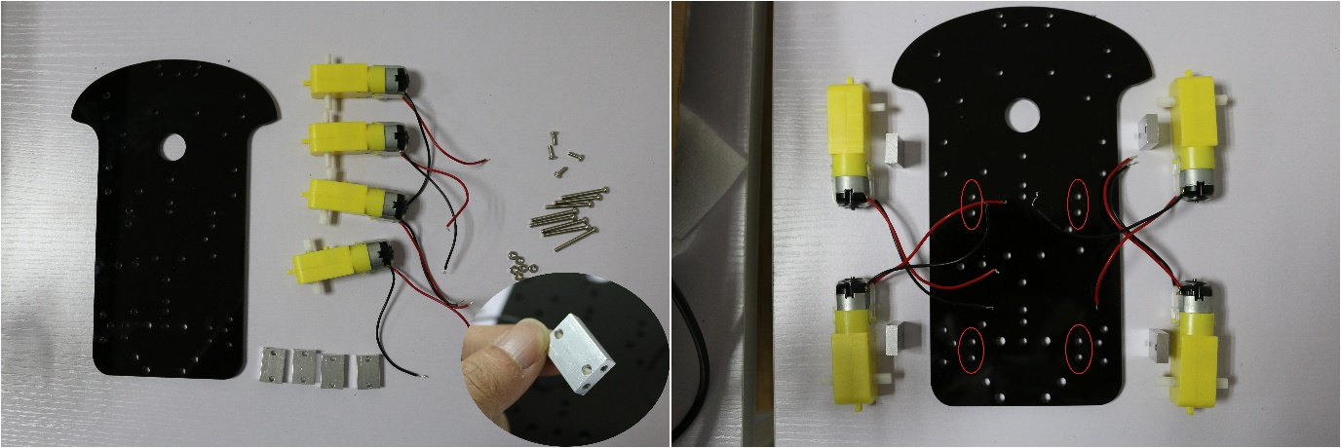
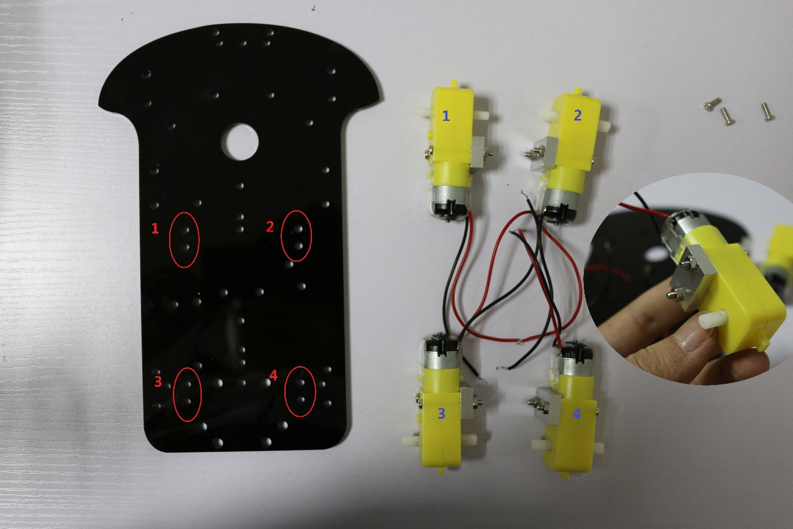
Warning：
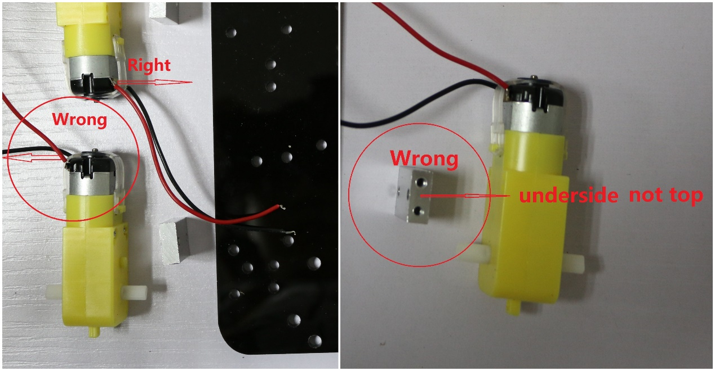

2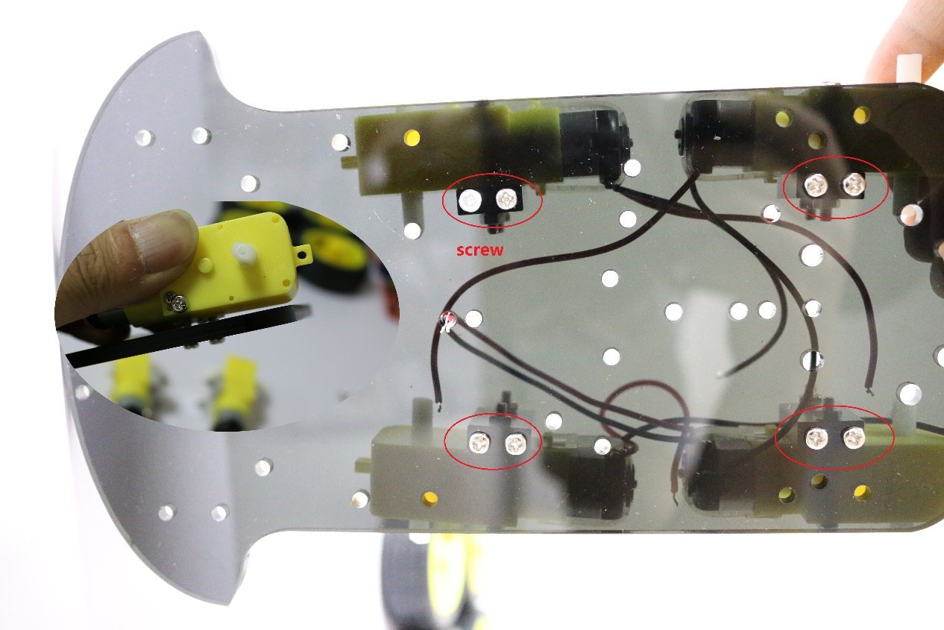
3（1pcs L298N motor driver board，2 short screw and 2 nuts）
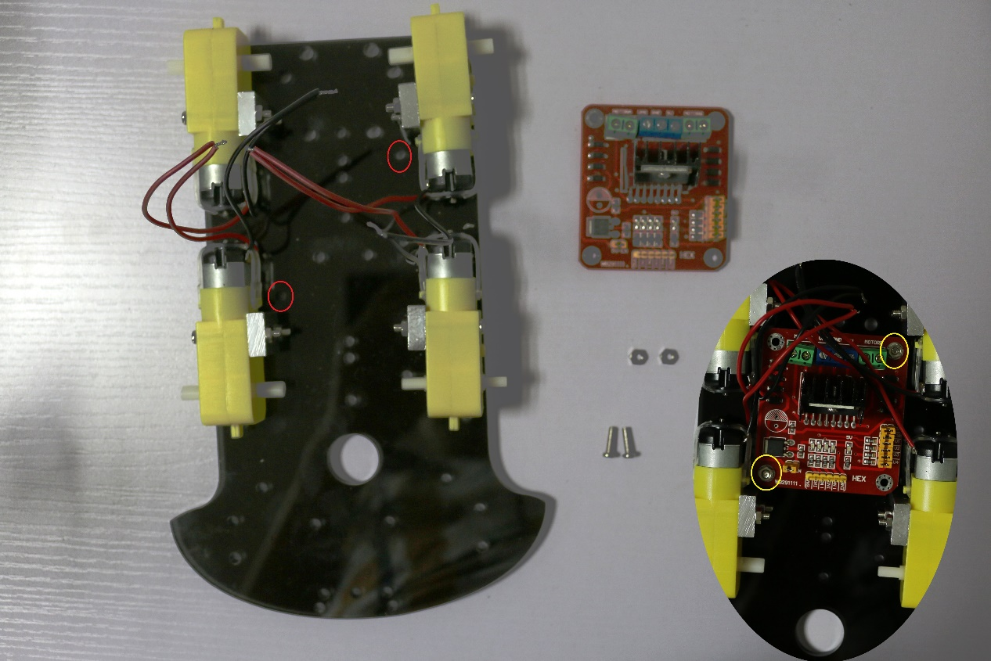

4.（1pcs Six 5th battery box and 3 step all things）
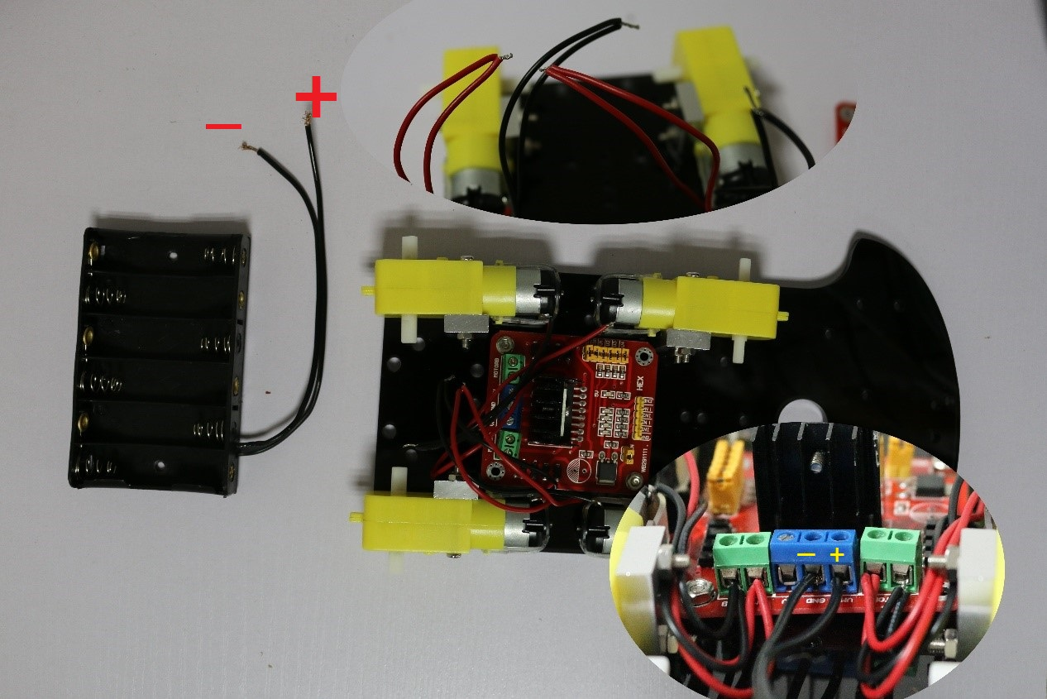
5（4pcs High quality type and 4 step all things ）
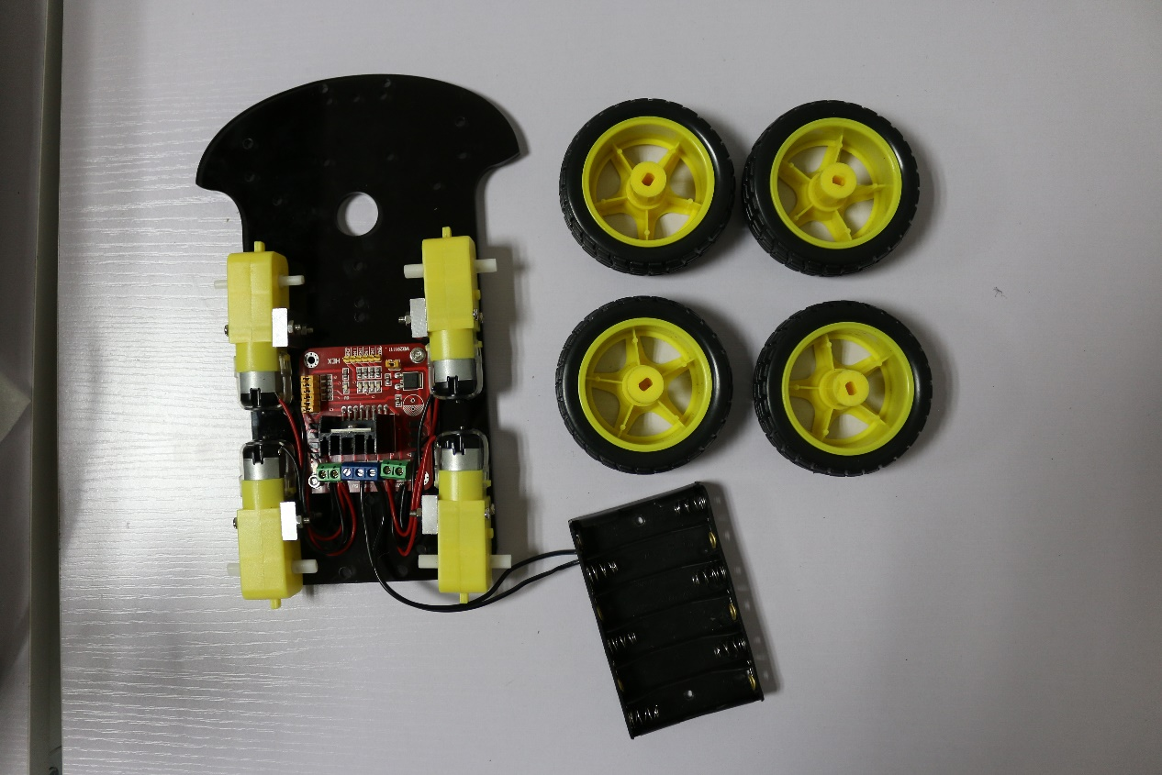

6（all 5 step+ M3*40 Copper stud +4 short screws ）
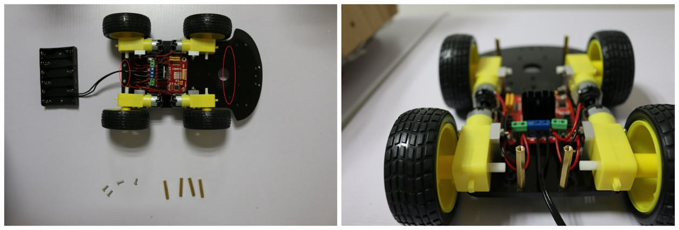
7（1pcs robot chassis+uno r3+4pcs screws4+4pcs nuts）
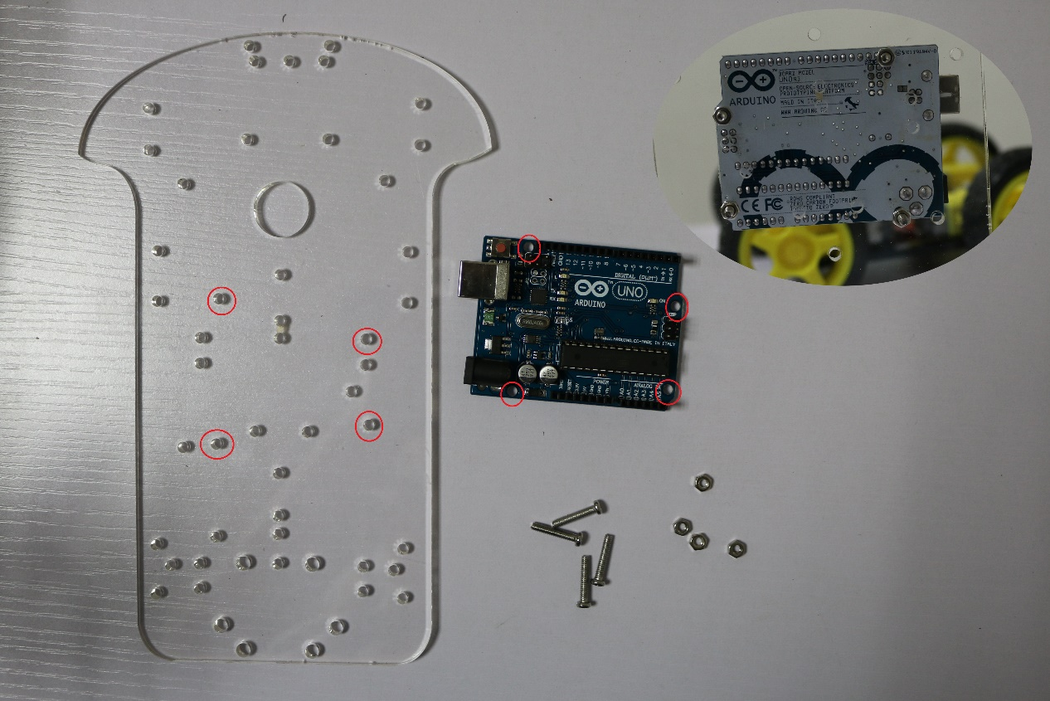

8（1pcs SG90 servo+1pcs holder）
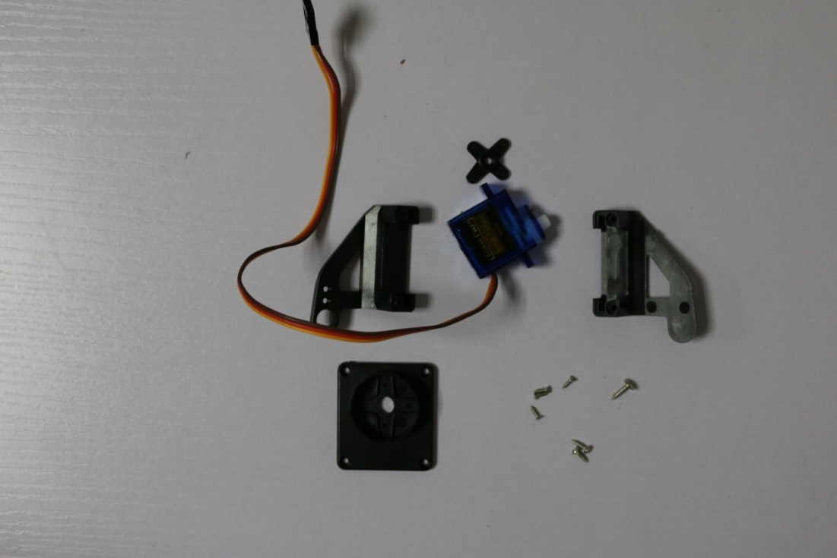
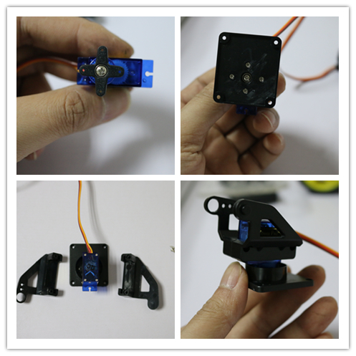

10(all things+2pcs M2 screws +M2 nuts)
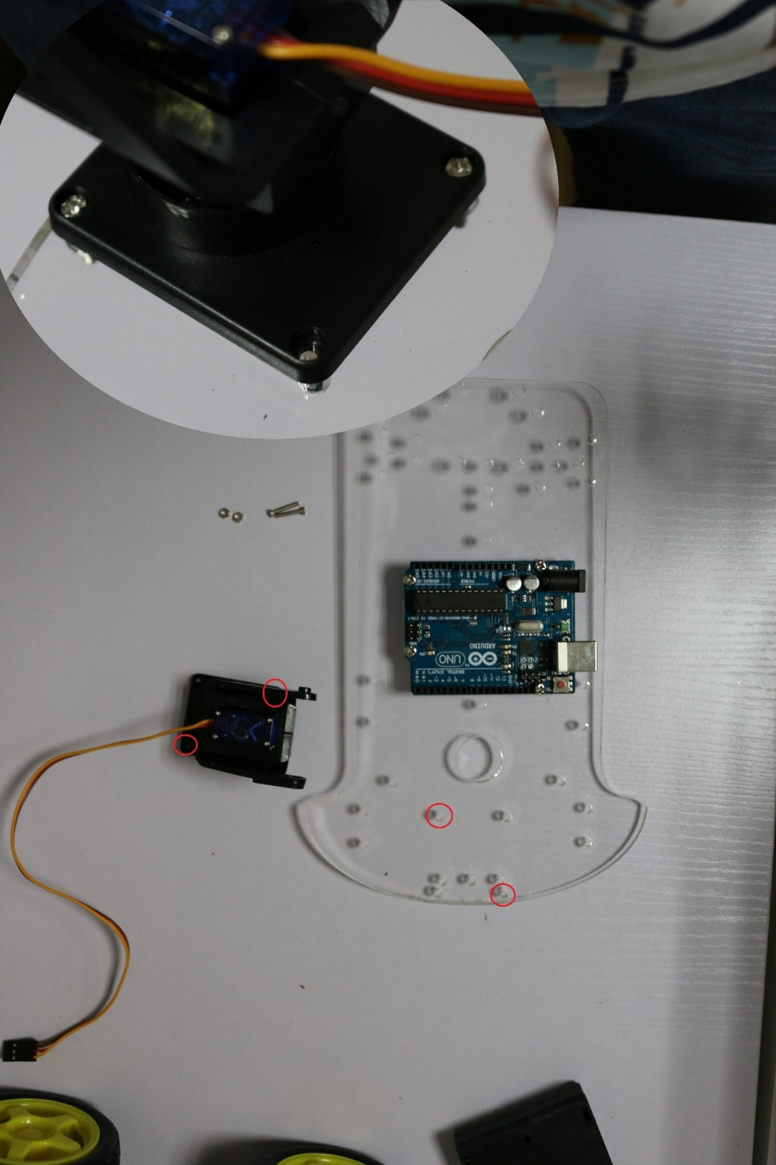
11(4pin dupont line+1pcs ultrasonic sensor module+V4+2pcs Nylon ties )
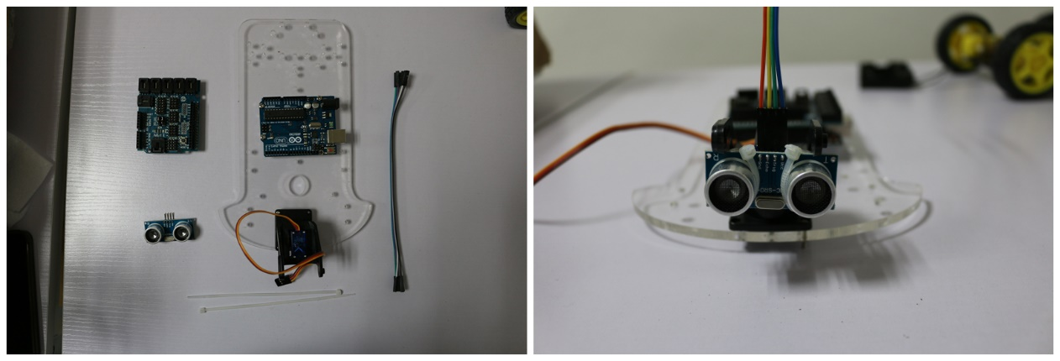
12.End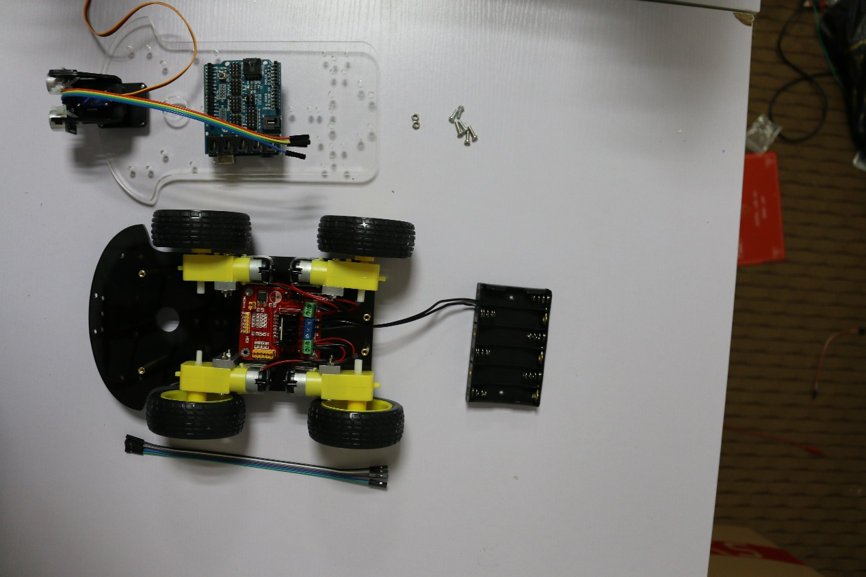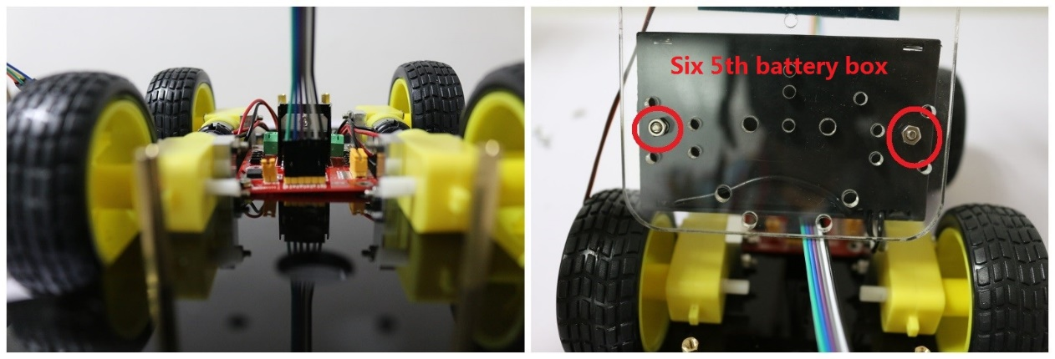
III .INTRODUCTION
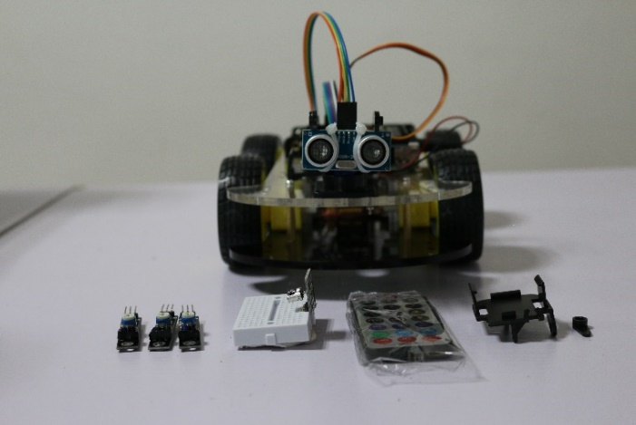
This introduction is only the simplest assembly, and the smart robot car does not have sure assembly .You must extend machine and connect line by your program. It is its interest.

