The detailed development datasheet download：

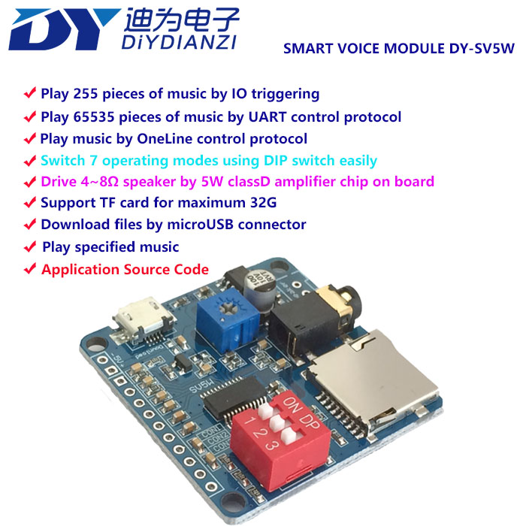
1．Product overview
DY-SV5W is a smart voice module developed independently by our company，Integrated IO trigger, UART protocol control, One_line single-bus protocol control, standard MP3 and other 7 operating modes setting by DIP switch; Drive 4~8Ω, 3~5W speaker by a 5W class D audio amplifier on board；Support MP3、WAV decoding; Support TF card for maximum 32G downloading music files directly by micro USB connector.
2．Product characteristics
1、Support MP3、WAV decoding。
2、Support sampling rate (KHz):8/11.025/12/16/22.05/24/32/44.1/48。
3、24bit DAC output，support dynamic range 90dB，SNR 85dB。
4、Support FAT16/FAT32 file system，support TF card for maximum 32G。
5、Drive 4~8Ω speaker by 5W class D amplifier chip on board。
6、Play 65535 pieces of music by UART control protocol; Play, Pause, Selecting music, VOL+/- and so on can be controlled，the communication baud rate is 9600bps。
7、Play 255 pieces of music by IO triggering;
8、Play music by One_line control protocol，Play, Pause, Selecting music, VOL+/- and so on can be controlled。
9、Switch 7 operating modes using DIP switch easily。
3．Definition of interfaces and functions
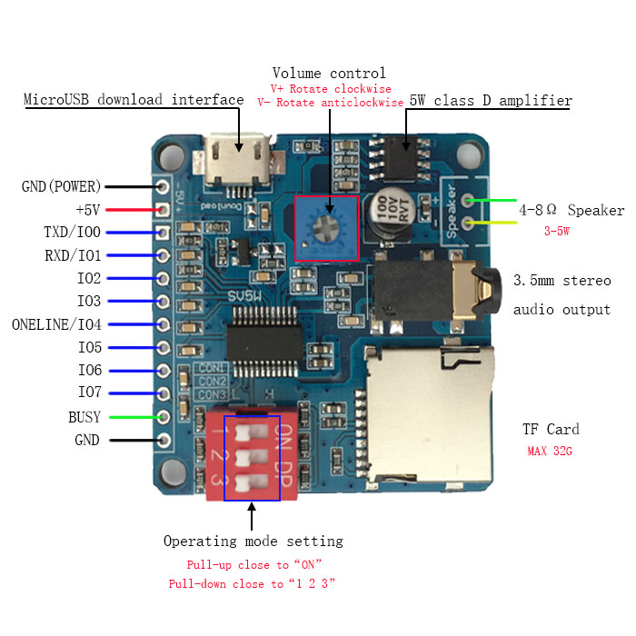
Definition of pins
PINS | Description
GND(POWER) | POWER GND
+5V | VCC (+5V)
TXD/IO0 | IO1 in IO triggering mode；TX in UART control mode，connect to RX of MCU
RXD/IO1 | IO1 in IO triggering mode; RX in UART control mode，connect to TX of MCU
IO2 | IO2 in IO triggering mode
IO3 | IO3 in IO triggering mode
IO4/ONE_LINE | IO4 in IO triggering mode；RX in One_line mode
IO5 | IO5 in IO triggering mode
IO6 | IO6 in IO triggering mode
IO7 | IO7 in IO triggering mode
BUSY | Output low level while playing music（0V），output high level when end playing（3.3V）
GND | Reference GND

IO electric characteristics
IO input characteristics
Symbol | Parameters | MIN | MAX | UNIT
VIL | LOW LEVEL INPUT | 0 | 0.8 | V
VIH | HIGH LEVEL INPUT | 2.7 | 3.3 | V
IO output characteristics
VoL | LOW LEVEL OUTPUT | 0 | 0.33 | V
VoH | HIGH LEVEL OUTPUT | 2.7 | 3.3 | V

Configuration of DIP Switch
Corresponds to the number on DIP switch | 1 | CON1 | “Pull-down” close to the “1” | “Pull-up” close to the “ON”
Corresponds to the number on DIP switch | 2 | CON2 | “Pull-down” close to the “2” | “Pull-up” close to the “ON”
Corresponds to the number on DIP switch | 3 | CON3 | “Pull-down” close to the “3” | “Pull-up” close to the “ON”

Control modes | Configure PINS |  |  | I/O Function
Control modes | CON3 | CON2 | CON1 | IO7 | IO6 | IO5 | IO4 | IO3 | IO2 | IO1 | IO0
I/O Combination mode 0 | 0 | 0 | 0 | I/O Combination trigger at falling edge and restoring to high level ，play 2^8-1（255）pieces music.
I/O Combination mode 1 | 0 | 0 | 1 | I/O Combination trigger while IOs keeping low level， play 2^8-1（255）pieces music .
I/O stand-alone mode 0 | 0 | 1 | 0 | 8th music | 7th music | 6th music | 5th music | 4th music | 3rd music | 2nd music | 1st music
I/O stand-alone mode 1 | 0 | 1 | 1 | 8th music | 7th music | 6th music | 5th music | 4th music | 3rd music | 2nd music | 1st music
UART control mode | 1 | 0 | 0 |  |  |  |  |  |  | RXD | TXD
One_Line mode | 1 | 0 | 0 |  |  |  | RXD
Standard MP3 mode | 1 | 0 | 1 |  |  |  | RPT | EQ | P/P/MODE | PREV/V- | NEXT/V+

NOTES：”I/O Combination mode 0”IO0~IO7 restore to high level after outputting
corresponding level, It's like triggering a button once. “I/O Combination mode 1” IO0~IO7 always keep the corresponding level
after Outputting corresponding level.
The difference between “I/O Combination mode 0”and “I/O
Combination mode 1”is that it still plays music when IOs restore to original
high level in “I/O Combination mode 0”, and it stops playing music when
IOs restore to original high level in “I/O Combination mode 1”
The difference between “I/O stand-alone mode 0” and “I/O stand-alone mode 1”is the same as above
4．Module size
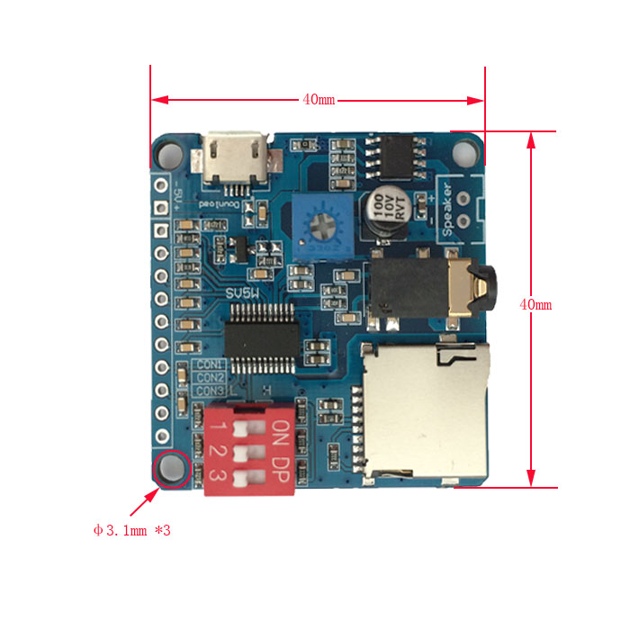
5. Modes operation instructions
5.1 I/O Combination mode 0
MCU I/O output corresponding level to trigger specified music and release the IO level to high, it stops playing music after completing playing current music; It will play the new music, if retrigger the music while playing. If keep the triggering state, it will keep playing circularly. The busy pin is always effective while playing.
NOTE：The music files must be named by five numbers such as 00001.mp3~00255.mp3
Music Control
IO7 | IO6 | IO5 | IO4 | IO3 | IO2 | IO1 | IO0 | Music playing
1 | 1 | 1 | 1 | 1 | 1 | 1 | 0 | 00001.mp3
1 | 1 | 1 | 1 | 1 | 1 | 0 | 1 | 00002.mp3
1 | 1 | 1 | 1 | 1 | 1 | 0 | 0 | 00003.mp3
1 | 1 | 1 | 1 | 1 | 0 | 1 | 1 | 00004.mp3
1 | 1 | 1 | 1 | 1 | 0 | 1 | 0 | 00005.mp3
1 | 1 | 1 | 1 | 1 | 0 | 0 | 1 | 00006.mp3
1 | 1 | 1 | 1 | 1 | 0 | 0 | 0 | 00007.mp3
...... | …… | …… | …… | …… | …… | …… | …… | ……
0 | 0 | 0 | 0 | 0 | 0 | 0 | 0 | 00255.mp3

5.2 I/O Combination mode 1
MCU I/O output corresponding level to trigger specified music and keep the triggering state, it will keep playing circularly. It will stop playing immediately when release to original high level anytime. The busy pin is always effective while playing.
NOTE：The music files must be named by five numbers such as 00001.mp3~00255.mp3
Music Control
IO7 | IO6 | IO5 | IO4 | IO3 | IO2 | IO1 | IO0 | Music playing
1 | 1 | 1 | 1 | 1 | 1 | 1 | 0 | 00001.mp3
1 | 1 | 1 | 1 | 1 | 1 | 0 | 1 | 00002.mp3
1 | 1 | 1 | 1 | 1 | 1 | 0 | 0 | 00003.mp3
1 | 1 | 1 | 1 | 1 | 0 | 1 | 1 | 00004.mp3
1 | 1 | 1 | 1 | 1 | 0 | 1 | 0 | 00005.mp3
1 | 1 | 1 | 1 | 1 | 0 | 0 | 1 | 00006.mp3
1 | 1 | 1 | 1 | 1 | 0 | 0 | 0 | 00007.mp3
...... | …… | …… | …… | …… | …… | …… | …… | ……
0 | 0 | 0 | 0 | 0 | 0 | 0 | 0 | 00255.mp3

5.3 I/O stand-alone mode 0
IO0~IO7 control 8 pieces of music，one IO only control one piece of music; IO trigger specified music by falling edge level and restore to original high level, it stops playing after completing playing the triggered music. It will play new music, if retrigger the music while playing；If keep the triggering state, it will keep playing circularly. The busy pin is always effective while playing.
NOTE：The music files must be named by five numbers such as 00001.mp3~00008.mp3
Music Control
IO7 | IO6 | IO5 | IO4 | IO3 | IO2 | IO1 | IO0 | Music playing
1 | 1 | 1 | 1 | 1 | 1 | 1 | 0 | 00001.mp3
1 | 1 | 1 | 1 | 1 | 1 | 0 | 1 | 00002.mp3
1 | 1 | 1 | 1 | 1 | 0 | 1 | 1 | 00003.mp3
1 | 1 | 1 | 1 | 0 | 1 | 1 | 1 | 00004.mp3
1 | 1 | 1 | 0 | 1 | 1 | 1 | 1 | 00005.mp3
1 | 1 | 0 | 1 | 1 | 1 | 1 | 1 | 00006.mp3
1 | 0 | 1 | 1 | 1 | 1 | 1 | 1 | 00007.mp3
0 | 1 | 1 | 1 | 1 | 1 | 1 | 1 | 00008.mp3

5.4 I/O stand-alone mode 1
IO0~IO7 control 8 pieces of music，one IO only control one piece of music; IO trigger specified music by low level, and it will keep playing circularly if keep the triggering state. It will stop playing immediately when release to original high level anytime. he busy pin is always effective while playing.
NOTE：The music files must be named by five numbers such as 00001.mp3~00008.mp3
Music Control
IO7 | IO6 | IO5 | IO4 | IO3 | IO2 | IO1 | IO0 | Music playing
1 | 1 | 1 | 1 | 1 | 1 | 1 | 0 | 00001.mp3
1 | 1 | 1 | 1 | 1 | 1 | 0 | 1 | 00002.mp3
1 | 1 | 1 | 1 | 1 | 0 | 1 | 1 | 00003.mp3
1 | 1 | 1 | 1 | 0 | 1 | 1 | 1 | 00004.mp3
1 | 1 | 1 | 0 | 1 | 1 | 1 | 1 | 00005.mp3
1 | 1 | 0 | 1 | 1 | 1 | 1 | 1 | 00006.mp3
1 | 0 | 1 | 1 | 1 | 1 | 1 | 1 | 00007.mp3
0 | 1 | 1 | 1 | 1 | 1 | 1 | 1 | 00008.mp3

5.5 UART Control Mode
5.5.1 Communication format
Full duplex serial communication；
Baud: 9600bps，Data：8 bits ，stop:1bit，Check: N.
Start-CMD Type-data length（n）-data1－data n－CRC(SM)
● ※ CMD CODE ：fixed AA.
● ※ CMD TYPE : Used to distinguish CMD types.
● ※ DATA LENGTH：The number of bytes of data in CMD
● ※ DATA ：Data in CMD，there is no data when the length of data is one, only CMD.
● ※ CRC ：The sum of all data from the start code to the end data before the CRC, and
select the low 8 bits.
※ DATA FORMAT：Send the high 8 bits first, and the low 8 bits follow.
5.5.2 Communication Protocol
The definition of data as follows.
1. Definition of playing state ：It is in stop state when power on.
※ 00(Stop) 01(Play) 02(Pause)
2. The definition of devices: It is in stop state when switch device.
※ USB:00 SD:01 FLASH:02 NO_DEVICE：FF
3. Volume：The volume all is 31 steps which is 0-30，it is 20 steps when power on.
4. The definition of playing modes：It is in single stop mode when power on.
※ Full cycle(00)：Play all music in sequence.
※ Single cycle(01)：Play the current music always.
※ Single stop(02)：Stop playing after playing the current music once.
※ Random broadcast(03)：Play music randomly in device.
※ Repeat folder(04)：Play all music in current folder in sequence.
※ Random broadcast in folder(05): Play music randomly in current folder.
※ Order play in folder (06)：Play music in current folder in sequence,
and stop when complete playing the last music.
※ Order play (07)：Play music in device in sequence, and stop when
complete playing the last music.
5. Definition of EQ：It is NORMAL (00) when power on.
※ NORMAL(00) POP(01) ROCK(02) JAZZ(03) CLASSIC(04)
6. Definition of combination play：It is combined by file name, the file is stored in DY folder，the file is named as two bytes , the number name is recommended such as 01.mp3, 02.mp3, and it is also named by two letters.
5.5.3 Definition of CMD
Control CMD
CMD | CODE | RESPONSE
Play | AA 02 00 AC | No return
Pause | AA 03 00 AD | No return
Stop | AA 04 00 AE | No return
Previous music | AA 05 00 AF | No return
Next music | AA 06 00 B0 | No return
Volume+ | AA 14 00 BE | No return
Volume- | AA 15 00 BF | No return
Previous folder directory | AA 0E 00 B8 | No return
Next folder directory | AA 0F 00 B9 | No return
End playing | AA 10 00 BA | No return

Setting CMD
CMD | CODE | RESPONSE
Volume setting | AA 13 01 VOL SM | No return
Cycle mode setting | AA 18 01 Mode SM | No return
Cycle times setting | AA 19 02 High Byte Low Byte SM  Times | No return
EQ setting | AA 1A 01 EQ SM | No return
Select specified music | AA 07 02 High Byte Low Byte SM  Music NO. | No return
Select device and path | AA 08 Length Device Path SM | No return
Switch to selected device | AA 0B 01Device SM | No return
Select specified file to interlude | AA 16 03 Device High Byte Low Byte SM  Music NO. | No return
Select specified path to interlude | AA 17 Length Device Path SM | No return
Select file but do not play | AA 1F 02 High Byte Low Byte SM  Music NO. | No return

Check CMD
CMD | CODE | RESPONSE
Check Play State | AA 01 00 AB | AA 01 01 State SM
Check Device Online | AA 09 00 B3 | AA 09 01Device SM
Check Current Playing Device | AA 0A 00 B4 | AA 0A 01 Device SM
Check Number Of all Music | AA 0C 00 B6 | AA 0C 02 High Byte Low Byte SM  Music NO.
Check Current Music | AA 0D 00 B7 | AA 0D 02 High Byte Low Byte SM  Music NO.
Check the first Music in Folder | AA 11 00 BB | AA 11 02 High Byte Low Byte SM  Music NO.
Check Number of Music In Folder | AA 12 00 BC | AA 12 02 High Byte Low Byte SM  Music NO.

UART Tuning Tool
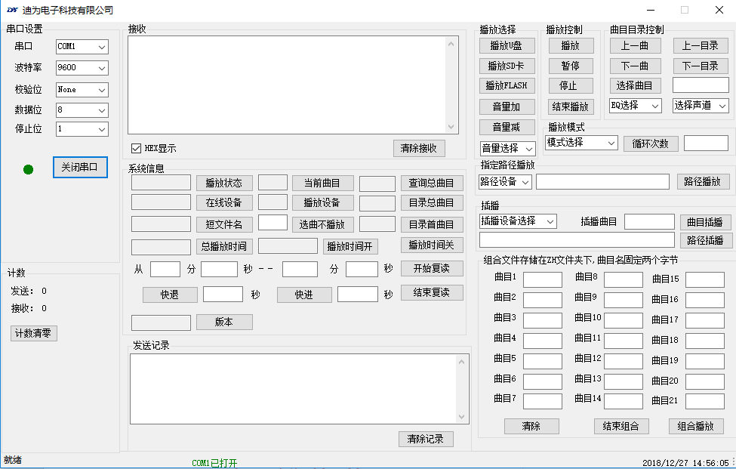
The detailed development data of UART mode, please check the“UART mode user’s guide”
5.6 One_line Mode
One_line control to play
Send the CMD as follow, send the low bit first. Send 89H as follow. The start flag is min 2ms.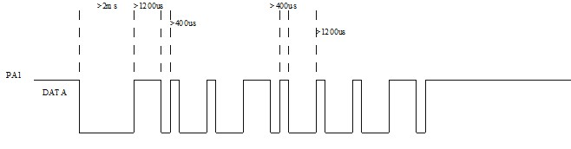
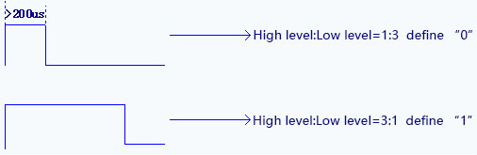
CMD format
CMD(HEX) | Function | Instruction
00 | NO.0 | Send the number first and function CMD is followed, such as setting volume to 21 steps, send “0x02” ”0x01” ”0x0C”
01 | NO.1
02 | NO.2
03 | NO.3
04 | NO.4
05 | NO.5
06 | NO.6
07 | NO.7
08 | NO.8
09 | NO.9
0A | Clear digital | Clear digital sent
0B | Select and enter | Setting function with digital
0C | Volume Setting | Setting function with digital
0D | EQ Setting | Setting function with digital
0E | Set cycle mode | Setting function with digital
0F | Set channel | Setting function with digital
10 | Select music to inter-cut | Setting function with digital
11 | Play
12 | Pause
13 | Stop
14 | Previous music
15 | Next music
16 | Previous directory
17 | Next directory
18 | SD card selected
19 | U Disk selected
1A | FLASH selected
1B | System sleep
1C | End playing
NOTE: “Select music” and “Inter-cut” are based the name of music; For example, the music name is “00123.mp3”,send the data“0x01”“0x02”“0x03”“0x0B” in sequence to complete selecting music.
The detailed development data of One_Line mode, please check the “One_Line mode user’s guide”

